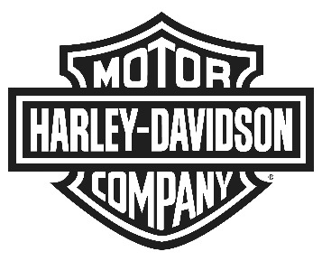
Harley-Davidson Europe Ltd
6000 Garsington Road, Oxford, OX4 2DQ, United Kingdom
NEWS

BRING YOUR OWN STYLE WITH THE NEW HARLEY-DAVIDSON BLACK LABEL SUMMER COLLECTION

Worn and distressed design meets contemporary cool

OXFORD (June 5th, 2015) – With good summer times just round the corner, Harley-Davidson has unveiled its Black Label Summer collection, designed to provide comfort and style for young adult riders as they continue to explore exciting new destinations and embark on tours of discovery.

The Black Label Collection is created for those who truly embrace their individuality and strive to live life to the fullest. The products from the summer collection are simplistic and modern while still retaining the legendary attitude of Harley-Davidson. The world is not something to live within, it is something to explore and experience and the Harley-Davidson Black Label Collection lets you set the rules and live life by them.

Harley-Davidson Black Label Summer Collection: Eclectic Apparel | Enduring Style

The men’s summer collection showcases eclectic detail and casual, summertime design while continuing to stay loyal to the enduring style expected from Harley-Davidson. It offers variety with denim jeans, cargo shorts, outerwear, and knit and woven tops with discreet branding found in badges, leather trim and hand crafted details. Inspired by you, the Trucker Denim Jacket features raw denim with a water-resistant and dirt-repellent protective finish. Unlined with a printed graphic inside, this brings a new level of freedom to graphic apparel and accentuates the fun, cool vibe perfect for summer 2015.

With new textures, colours and washes, the women’s summer collection offers a more fashion-forward look, giving the new generation confidence to take to the road. Leather jackets, knit tops and dresses continue to appear in the range with improved lacing and hand drawn finishes. Worn and distressed accents on items such as the Denim Trucker Jacket along with soft applique and texture provide a fresh look to the Harley-Davidson Black Label Collection, ensuring ‘stand out’ from the crowd.

Familiar offerings such as the vintage Iconic Tee selection are now folded into the seasonal collections for both Men and Women and are available in V-neck, crew-neck, muscle Tee and Tank styles. Tee and Tank graphics are inspired by neon signs, color stained graphics and eagle iconography.

All items can be purchased at your local Harley-Davidson dealership. For more information about the collection, visit www.Harley-Davidson.eu/motorclothes.

---

About Harley-Davidson Motor Company®
Harley-Davidson Motor Company® produces custom, cruiser and touring motorcycles and offers a complete line of Harley-Davidson motorcycle parts, accessories, riding gear and apparel, and general merchandise. For more information, visit Harley-Davidson's website at www.h-d.com.

